This n That

An e-mail newsletter from Agapé Athletics Club

Editor: Marieta Bortoli 082 466 7031 16 July 2018 www.agape.org.za

E-mail: marietabortoli@gmail.com

NB

- Next league race – SMU Half Marathon – 25 August
- Spring function – 1 September
- Agapé race (Jacaranda City Challenge) – 13 October. Members to assist. PLEASE DIARIZE !!!!!!

Editorial

With schools starting again this week, everything should be back to normal. Races should attract more runners but with the cold weather I suspect that there will be a lot of runners still staying at home and under the blankets for another week or two.

We are looking for a few members to assist as a marshal captain at our race in October. Should you be available please contact me.

Notice Board Additions

◊ Castle Walk Road Race
◊

Attachments

□ 2018 AGN Fixtures (v9)

Birthday Greetings

May God look down and bless you now when your birthday’s here and keep you in His loving care each day throughout the year, and may He grant you happiness in everything you do – today, tomorrow, always, every day your whole life through!

Pieter Denysschen 16 July | Annelie Jacobs 19 July
Alison Potgieter 22 July | Pierre Cronje 27 July
Maureen Mashiane 27 July | Olivia Kruger 29 July
Tania Oelofse 29 July | Hester Strydom 29 July
Adele Boshoff 31 July

Personalia

Welcome new and former members

Congratulations

Congratulations to the following members:

15km Cyclone Trail Run
Christa van Aswegen 1st 50 – 59 2:05:56

Thank you’s

In the mailbox

General
Clothing available:
Buffs @ R100
Ladies skirts @ R200
Second skins @ R220
Age tags @ R30

Please contact Marietjie if you wish to purchase some of the items:
Cell: 072 541 7268 E-mail: ventermarix9@gmail.com
The items will also be available at races, please visit our gazebo

Race reports/Upcoming race information

Hall`s 21 & 10 km 7 Julie 2018 – Marinda Cilliers
Hierdie is `n wedloop wat ons al jare dreig om te doen en uiteindelik Saterdag gedoen het. Die voorafinskrywings die vorige dag het sonder moeite verloop.

Die verkeer die oggend was baaaaie minder as wat ons gewoond is van Pretoria-wedlope. Dit was `n plesier om net te arriveer en rustig te wees voor die wedloop om 7: 00 begin het. Ek het nie besef die hele roete is op die Halls plaas nie, maar het dit steeds geniet. Die eerste 10,5 km was `n geleidelike klim op grondpad, los sand, trekkerpaaie ens. Die omgewing het gedurig verander en my baie aan die Skukuza halfmaraton laat dink.

Waterpunte was goed beman en goed toegerus met lekker eetgoed. Die 21 het uit die aard van die saak minder atlete getrek, maar die omgewing was so mooi, dat dit eintlik lekker was om soms net alleen te hardloop. Met die omdraai eers het ek besef ons hardloop nou afdraende met die mooiste uitsigte oor Nelspruit en omgewing.

Nelspruit het sy koudste week daardie week gehad en dit was bewolk die hele wedloop deur, maar nog steeds nie so koud soos Pretoria in Julie nie.

Elke atleet het aan die einde `n sakkie avokado’s gekry. Wat `n lekker bederf!

Hierdie wedloop was vir my goeie voorbereiding vir die Skukuza 21 oor `n maand en sal my definitief d.v. volgende jaar weer sien.

VASBYT Saturday 14th July 2018 - Elbert Loubser
What a weekend this has been!

Kevin Anderson in the Wimbledon final. France winning the Soccer world cup in Russia. The World Choir Games 2018 held here on our doorstep in Pretoria, came to an end. So, one could be excused if it slipped the mind that there was a road race/bundu bashing/extreme trail adventure which ran its course on Saturday morning at the Voortrekker monument, sponsored by Afriforum, aptly called the VASBYT.

https://www.facebook.com/groups/Afriforumspringbokvasbyt/?multi_permalinks=2112250055711151&notif_id=1531729455726008&notif_t=group_activity

Flyer says: This is an Adventure and a Challenge. Please be prepared to Run / Walk more than half of this race on gravel road and on very challenging mountain tracks. Well, well, well! If that ain't warning enough, then one should not even consider uttering the words: 'Eish! This is tough/exhausting/a killer/nasty/back breaking' or anything similar! :-) There was ample warning!

The opening ceremony (07:20, MC Pete van der Merwe) of the 13th Vasbyt included a 'second ever' flyby of a total of 5 (yes, five) Harvards, Scottish band playing, prayer, a one-minute silence in honour of those who sacrificed their lives in battle, a trumpet playing 'The Last Post' (yip, many a tear spilling over) etc. By now we expected the canon shot, but it still evokes an involuntary skitter/jump from several athletes (including me). A fairly chilly breeze wafting, although one needs to admit that it is/was actually a tad warmer than previous years (warmer, as I only needed to don one second skin). Leon Bezuidenhout (before hand) handed out some black arm bands, to wear in protest of ASA which is apparently considering banning 'our' Comrades 2018-woman winner, Ann Ashworth, due to her sensible withdrawal from the 100k relay team: http://runningmann.co.za/2018/07/03/ann-ashworth-athletes-champion/#.W02F3dUza1s (Eish!)

Progress on the first part of the 25 kay (past the Wall of Remembrance + In Honour of the Unknown Soldier) 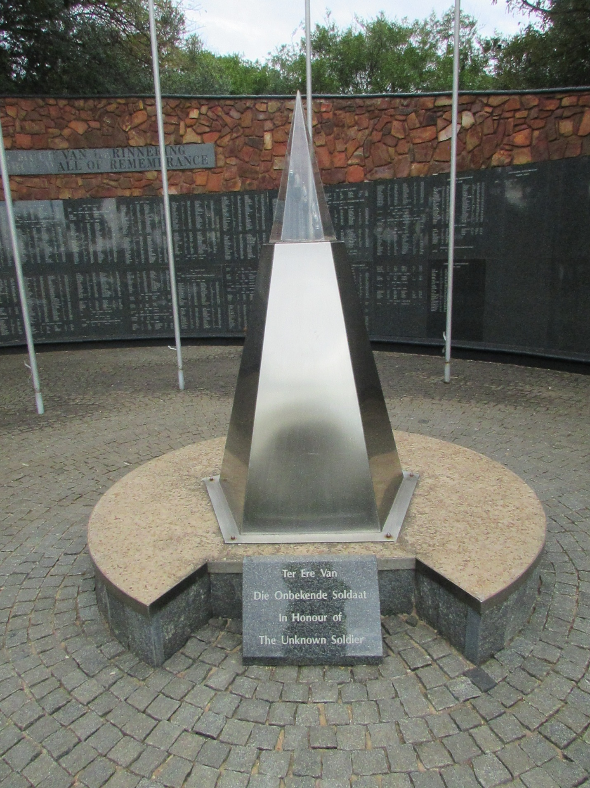
run was on smooth tarmac (the 24 kay count down board appropriately left in our wake), then at the monument gate entrance we swerve away from the 10 km participants. Good cloud cover at this stage. Down towards the North-Western entrance, up past Exxaro (this corner used to be known as the 'Wawiel sirkel', before extensive 're-inventive' traffic flow construction took place) and a steep climb up to and past the water reservoir, some flooding and mud at the second watering point (which we survived :-)) up towards the 'radio' mast (a biiiig white VASBYT written on the road), back down, re-entry on the side road, then the serious 'bundu bashing' commenced. Many a stone/'mini rocks' are disturbed from their resting place as running shoes nick, slide over, trample, dig in, to adjust for traction to climb or decelerate. Swerving left, right, up, down, jawing action around bends, chevron tapes warning of low hanging branches, 'Oops!', regain balance after that slip and slide. Yip, once again confronted by 'the pure cussedness of inanimate objects' :-).

Then a slight breather (less rocks/stones) on more stable gravel/sand ground past the fence adjacent to Eeufees road. A curve back towards a view of the Gauteng train tracks (in the distance). Up and down and around and at 7 kays to go, the first of 'the terrible six inclines' (TTSI) needs to be negotiated. The watering point provides a necessary and much appreciated 'stop over' to regain and top-up on physical energy and mental strength. Up the tar, right turn, left turn, the second TTSI just after 6 kays to go (yip, 19 kays of 'hard going' already 'conquered'). A flat rocky single path, then the dreaded 3rd TTSI. Here several of us actually stop for a full minute to regain some measure of breathing, as the lungs fight to supply the muscles with oxygen. That mast looms up through the brush, left up towards Fort Schanskop and the statue of Danie Theron (for me this is TTSI number 4 which only loses its grip as one enters the fort through the narrow-walled pathway). Watering point (in the lovely-lovely cool shade) at the bottom 'gate' of the Fort. Aaaaaaaah, now some downhill, which sounds pleasant, yet this is where one needs to keep the momentum. Quads and feet and every other muscle is complaining. Contrary to popular belief, the 'easier' down sections are where one really needs to do the actual 'Vasbyt' part, as these are the sections which keep one 'in the game', so to speak (well for me personally, if no-one else wants to agree). An added bonus is the slight breeze which was sorely absent on the climb. The pounding intensifies past the 3 kays to go. Lovely down section this, yet painful. 4th TTSI, yep, that piece up and over to the 2-kay mark.

What is worse than that subtle smell wafting from the kitchen? Body now craving for a mouthful of hot-tasty-stewing-gravy-on-mash/rice type of rich meaty protein. Watering point at the gate, now the worst TTSI of them all, number 5, the pull up through the cut grass path towards the Monument (looming in front), chest heaving and grasping for oxygen, the heat of the sun now making its presence felt with a 'bang', eventually a slight twist to the right allows the breathing to stabilize a little, a slight adjustment left and out onto the tar. The 1 kay to go board becoming visible (there is actually some shade here). So close, yet still so faaaaaar. Up the stairs of the monument (TTSI number 6), legs wobbly, arms assisting the knees for the 'double step' broad stairs, breathing and heart rate shooting up again. Beautiful section (and a huuuge privilege granted to race participants) around the monument on the inside of the 'wagon wall'. Appreciated temporary 'shade break' behind the monument. Ouch! Going down the monument stairs several grades worse on the body than the recent climb up those stairs.
Slope downhill on the tar, left and left and grass and steep down curve to the right and grass and dust and cheers (crowd and Sandy van Aswegen and time keepers) and Finish line and medal and 'fudge' and Coke and........... Phew! Made it! Another hard day in Africa.

Thank you Leon Bezuidenhout and club members and assisting volunteers for another memorable VASBYT.
Cherry on the cake (thank you Leon): My framed permanent number (nope, your eyes are not deceiving you, it is a '1') has now been joined by its sibling, to soon make its appearance on my running vest.
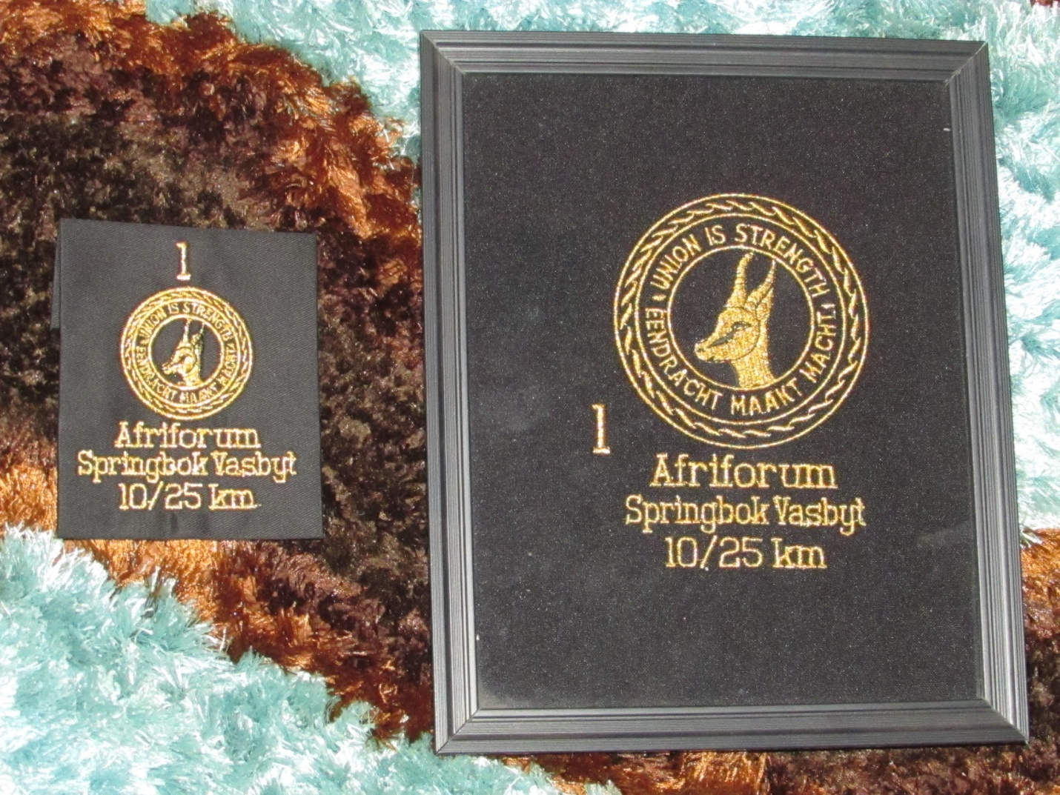

To all those athletes who have done the 'vasbyt' 10 times to advance to their VASBYT permanent numbers: WELL DONE!!!

Race Results
Afriforum Springbok Vasbyt (AGN) 5km race - 2018-07-14
Position | Initials | Surname | Sex | Age | Finish Time
23 | E | Dirkse Van Schalkwyk | F |  | 00:25:19
Afriforum Springbok Vasbyt (AGN) 10km race - 2018-07-14
Position | Initials | Surname | Sex | Age |  | Finish Time
35 | J | Van Der Merwe | M |  |  | 00:53:50
90 | D | De Beer | M |  |  | 01:02:05
266 | B | Boyes | F | 53 |  | 01:15:59
287 | T | Oelofse | F |  |  | 01:17:37
321 | K | Nurden | M | 83 |  | 01:20:10
353 | D | Frost | M |  |  | 01:21:21
435 | R | Stutterheim | M |  |  | 01:25:47
440 | A | Te Reh | M |  |  | 01:26:08
703 | M | Stadler | F | 77 |  | 01:55:14
Afriforum Springbok Vasbyt (AGN) 25km race - 2018-07-14
Position | Initials | Surname | Sex | Age | Finish Time
57 | K | Booyse | F |  | 02:10:57
58 | K | Imrie | M |  | 02:10:58
229 | M | Van Der Westhuizen | M |  | 02:50:59
232 | M | Hattingh | M |  | 02:51:27
247 | G | Vermaak | M | 38 | 02:54:59
248 | D | Strydom | M | 37 | 02:55:01
348 | V | Vermaak | F | 37 | 03:10:05
369 | J | Krause | M |  | 03:15:14
477 | E | Loubser | M |  | 03:59:49

League results

Training/Health snippets

Why Walking is Important for Exercise

Walking is the ideal form of exercise for those just starting out.

Many aspiring runners dismiss “walk” as a four-letter word, as if it’s cheating, quitting, or not really exercising. But walking is actually the ideal form of exercise for most people who are starting out. It’s free, and you can do it anytime in any place; no special skill, pricey membership, or equipment (except good shoes!) is required. It is the best way to build strong bones, muscles, and tendons without getting hurt. And it’s the easiest way to develop the fitness you need to run down the road.
Here’s more on the power of walking:
It builds your foundation for running. Walking puts your legs and arms through the same general range of motion as running, but without the same impact on your bones and joints, and without the same risk of getting hurt. Plus, it gives you an opportunity to explore convenient, safe, traffic-free routes, which will become super important as you get into a routine.
It keeps you healthy and injury-free. When you’re running, at some point both feet come off the ground at the same time, and when you land, the impact can be up to two to three times your body weight. But when you’re walking, one foot is on the ground at all times. That drastically reduces the impact on your bones and joints compared with running.
Form is important. Most walkers find an upright posture to be the most natural and comfortable. Take short steps to avoid over striding, which can cause aches and pains in your legs, feet, and hips. Keep your feet low to the ground and step lightly.

Your thought for the week

You can't be happy unless you're unhappy sometimes!

Your smile for the week

Three women go down to Mexico one night to celebrate college graduation. They get drunk and wake up in jail, only to find that they are to be executed in the morning, though none of them can remember what they did the night before.
The first one, a redhead, is strapped in the electric chair and is asked if she has any last words. She says, "I just graduated from Trinity Bible College and believe in the almighty power of God to intervene on the behalf of the innocent." They throw the switch, and nothing happens. They all immediately fall to the floor on their knees, beg for forgiveness, and release her.
The second one, a brunette, is strapped in and gives her last words. "I just graduated from the Harvard School of Law and I believe in the power of justice to intervene on the part of the innocent." They throw the switch and again, nothing happens. Again, they all immediately fall to their knees, beg for forgiveness and release her.
The last one, a blonde, is strapped in and says, "Well, I'm from the University of Texas and just graduated with a degree in Electrical Engineering, and I'll tell ya right now, ya'll ain't gonna electrocute nobody if you don't plug this thing in."

Something to ponder over / something spiritual
How to Overcome Negative Thinking and Live with Hope
Do you have hope for your future? Or do you generally expect negative or disappointing things to happen?

I was taught to be negative when I was growing up. I lived in an abusive atmosphere with negative people, alcoholism, fear, ranting and raving… As a result, I developed an attitude that it was better to expect nothing good than to expect it and be disappointed when it didn’t happen. I often wondered, what’s going to go wrong next?

It wasn’t until I was an adult that I realized I was living with evil forebodings, which created a vague feeling around me all the time that something bad was going to happen.

Then one day, God spoke to my heart about this. He showed me that I was dreading that something bad was going to happen, but He wanted me to expect good things to happen. Jeremiah 29:11 (AMP) tells us that God’s thoughts and plans for us are “for welfare and peace and not for evil, to give you hope in your final outcome.”
God wanted me to say, “Something good is going to happen!”

The truth is, God doesn’t work in us through negative attitudes full of self-pity, laziness, passivity or an “everybody owes me” perspective. God works through faith! But before we can have faith, we have to have hope.

I Became a Prisoner of Hope!

Hope is favourable and confident expectation; it’s an expectant attitude that something good is going to happen and things will work out, no matter what situation we’re facing. Zechariah 9:12 (AMP) says, “Return to the stronghold [of security and prosperity], you prisoners of hope; even today do I declare that I will restore double your former prosperity to you.”

I like the phrase “prisoners of hope.” Think about it… If you’re a prisoner, you have no choice about it – you can’t be negative. And when times are tough or you’re dealing with disappointment, hope will cause you to rise up in faith and say, “God, I praise You and I believe You’re working on this situation and working in me. My faith, trust and hope are in You!”

Hope is determined and doesn’t give up. God wants us to be locked up in hope, trusting that He can change what needs to be changed, that we can do what He wants us to do, and that all things are possible with God. If we will be steadfast in our hope, we can’t lose – we have to be winners in life.

When God called me to ministry, it didn’t happen overnight. There were many years of preparation and building up what is now a worldwide ministry. During those years, I wanted to quit many times. But my testimony is, I’m still here! And if you won’t give up, you’ll have victory too.

Human nature is impatient, selfish and wants things quickly. Why is it that although it takes us years to get into our messes, we expect God to get us out of them in a few days? In John 16:33, Jesus tells us that we are going to have tribulation, trials, distress and frustration in this world, but in spite of that, we can be of good cheer and take heart. Why? Because He has overcome the world. And when we live in Him, we become overcomers too!

That’s why Jesus died for us. He came to save us from sin and death and to give us abundant life – now. And I’m determined to have everything Jesus died to give me.

Make a decision to have everything Jesus died to give you. You have to do it on purpose. Be determined to do what God wants you to do and refuse to live with negative expectations. Ask God to help you live in hope and declare by faith, “Something good is going to happen to me!”

Cancelled Races

Notice Board

Useful Links:
www.raceresults.co.za/flyers - for the latest race pamphlets
www.agn.co.za/#League for the latest league logs and the league points you earned
http://www.agn.co.za/Docs/2018/Walking/AGN%20road%20walking%20stds%20ref%20685.pdf
AGN 2017 RW qualifying standards and selection criteria
www.runawaysport.co.za Run-A-Way Sport’s web site
www.verticalhorison.co.za Trail Running www.trailseries.co.za Trail Running
http://www.mastersathletics.net/Age-Graded-Calculator.2595.0.html Age Graded Calculator
http://www.sportsinjuryclinic.net/symptom-checker By clicking where it hurts then ticking which symptoms most apply to you we can give you an indication of what injuries may apply.

Saturday 21 July Long Walk/Run to Freedom 21.1/10/5 km
Race Organisers: Run/Walk for Life
Venue: Atterbury Value Mart, Atterbury Road, Faerie Glen

 | 21.1 km | 10 km | 5 km
Entry fee | R 80 | R 60 | R40
Start Time | 07:00 |  | 07:15
Cut-off | ??

Wheelchairs and strollers welcome

No pets

No iPods or listening devices are allowed

Pre-entries at: Sportsmans Warehouse Atterbury Value Mart;

www.entrytime.com

Saturday 28 July Zwartkop Road Race 21.1/10/1 km
Race Organisers: Gereformeerde Kerk Wierdapark in conjunction with Denel Athletics Club
Venue: Zwartkop Lapa, Wierda Road, Centurion
GPS: S 25 50’14.25 E 28 07’28.46

 | 21.1 km |  | 10 km | 1 km kiddies race
Entry fee | R 100 |  | R70 | Free
Entry fee 70+ | Race day only 50% of above
Entry fee Blind runners & wheelchair athletes | Race day entry only  Free
Start Time | 07:00
Cut-off | 04:00 | 02:00

No pets

No iPods or listening devices are allowed

Pre-entries at: Run-A-way Sport; Sweatshop Southdowns & Dunkeld; Sportmans Warehouse Centurion; Natural Runner Highveld

www.entrytime.com

Thursday 9 August Castle Walk Road Race 10/5km
Race Organisers: Fusion Sports
Venue: Castle Walk Shopping Centre, c/o Nossob & Swakop Street, Erasmuskloof

 | 10 km | 5 km
Entry fees | R 70 | R 50
Children under 12  60+/Children under 5 |  | R 30  Free
Start time | 07h00 | 07h15
Time Limit | ??
No pets or wheelchairs on the 10km race

Pre-entries at: Run-Away-Sport; Sweat Shop Southdowns & Dunkeld West & Fourways Crossing; Curves Castle Walk Centre

2018 AGN LEAGUE FIXTURE LIST
EVENT | DISTANCE | DATE | LEAGUE
 |  |  | RR | RW
SMU Half Marathon | 21.1/10 km | 25/08 | X | X
Clover Irene Spring Race | 21.1/10 km | 29/09 | X | X
CSIR Road Race | 21.1/10 km | 20/10 | X | X
Tom Jenkins | 21.1/10 km | 17/11 | X | X

Masters Athletics Fixture list

Local meetings
4 August 2018 FSMA (throws & jumps) Pelliespark, UFS
20 October 2018 SWD Oudtshoorn
10 November 2018 Free State Bloemfontein

Africa Champs
December 2018 Africa Championships Tunisia

International Championships
4-16 September 2018 WMA Champs Malaga, Spain
24-30 March 2019 WMA Indoor Torun, Poland
28/9-6/10 2019 30th Summer universiade Naples, Italy
20/7/2020 – 1/8/2020 World Masters athletics Champs Toronto, Canada

Time Trials:

Centurion - Wednesdays at 17:15
Lewende Woord Centurion
Contact Marinda 654 5800 (h) / 082 720 9017

Rietondale - Thursdays 17:30
North Street, Rietondale (Rietondale Park in the street before the Crawford Stadium)
Contact Hennie Venter 082 676 6792

Zita Park - Tuesdays at 17:30
Zita Street, Zita Park, Garsfontein
Contact Hennie Venter – 082 676 6792 Marietjie Venter – 072 541 7268

Gazebo Enquiries

Hennie Venter – 082 676 6792 Marietjie Venter – 072 541 7268

Intercessor:

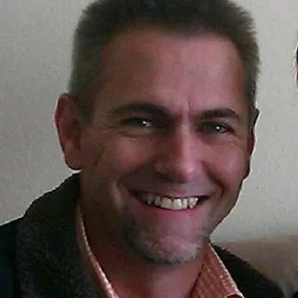

Fred Harding 076 777 7786

Agapé Executive 2017/2018

Name | Position | Telephone number | E-mail address
Marieta Bortoli | Chairperson & editor | 012 331 2089  082 466 7031 | marietabortoli@gmail.com
Hennie Venter | Registrar, club captain & Vice-chairperson | 082 676 6792 | henniev@seng.co.za  join@agape.org.za
Marilett Jenkins | Secretary | 082 837 2142 | marilett.jenkins@mervitzmalan.co.za
André Breytenbach | Treasurer | 083 566 1090 | andreb@geoscience.org.za
De Wet de Beer | PRO | 082 373 2987 | dewet@styletechnique.co.za
 | Race organiser
Fred Harding | Intercessor | 076 777 7786 | fwhard@gmail.com
Marix Venter | Clothing co-ordinator | 072 541 7268 | Ventermarix9@gmail.com
Suzette van Staden | General activities | 083 290 6280 | suzettevs971220@gmail.com
Gustav Brink | Statistician | 083 417 8431 | gustav.brink@gmail.com

Photo corner

Agapé Executive

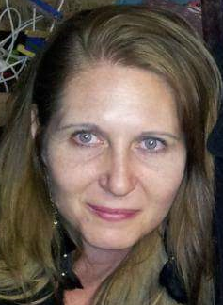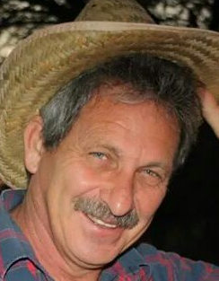
Marieta Bortoli Marilett Jenkins Hennie Venter

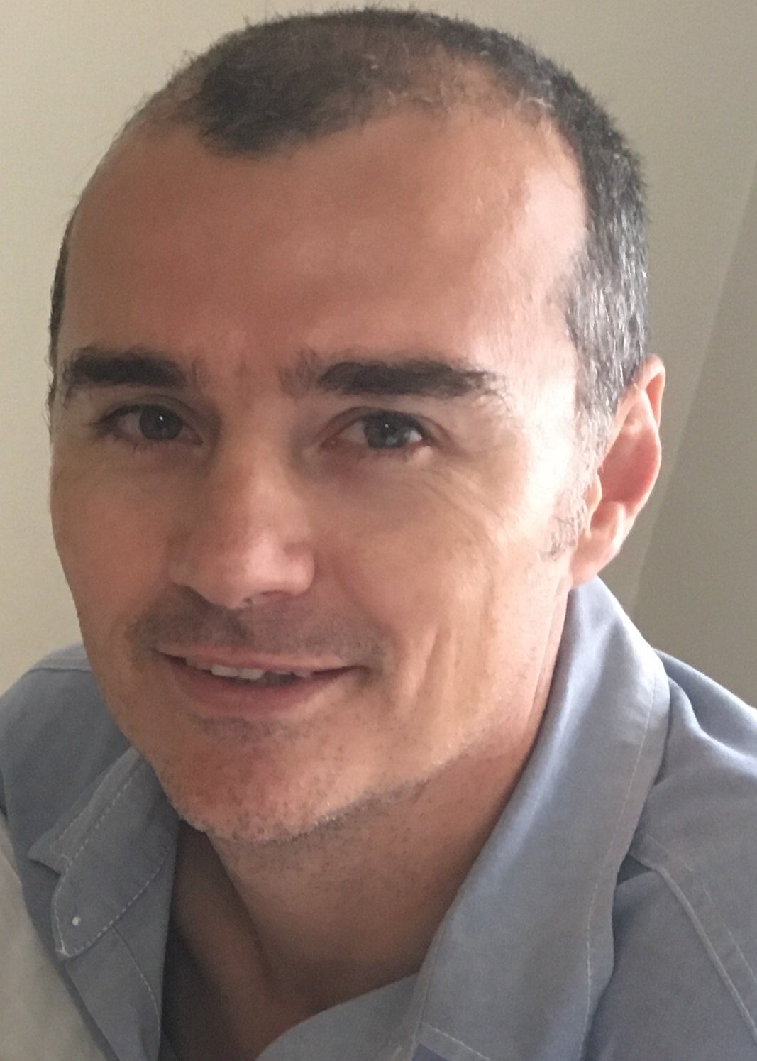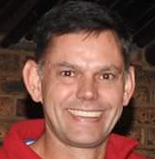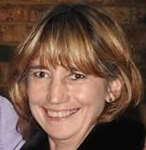
De Wet de Beer André Breytenbach Marix Venter

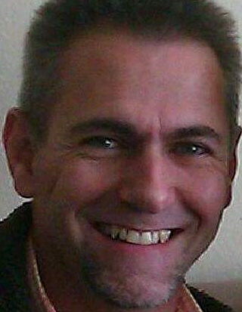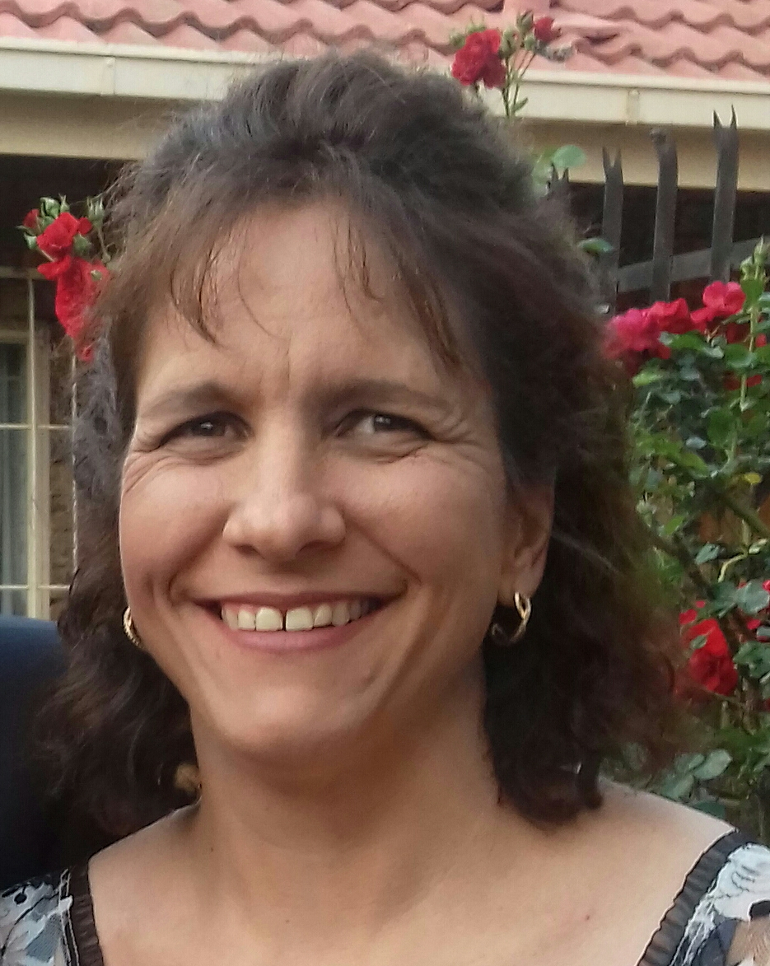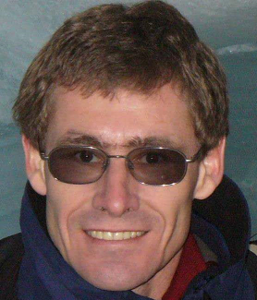
Fred Harding Suzette van Staden Gustav Brink (Ex-officio)

